**DBMS LAB**

**ASSIGNMENT-9**

**SNEHA SINGH**

**20198023**

**IT 5 B2**

**Q1) Write a PL/SQL program to print “HELLO WORLD”.**

BEGIN

dbms_output.put_line('Hello World');

END;

/

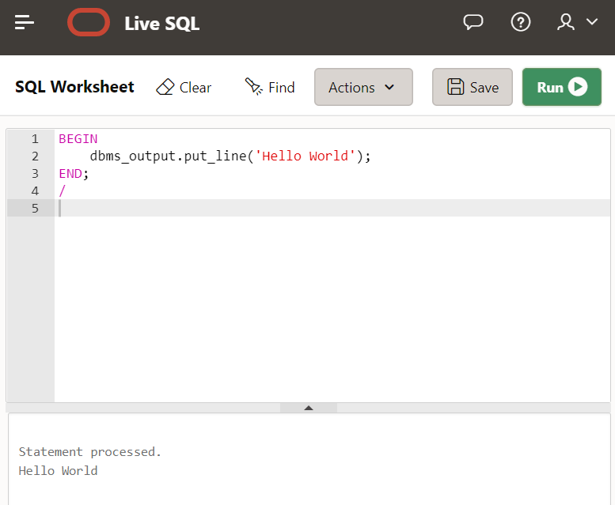

**Q2) Write a PL/SQL code for inverting a number. (Example: 1234 –4321)**

DECLARE

a number:=1234567;

b number:=0;

c number;

BEGIN

while a>0

loop

c:=a mod 10;

b:=b*10+c;

a:=floor(a/10);

end loop;

dbms_output.put_line(b);

END;

/

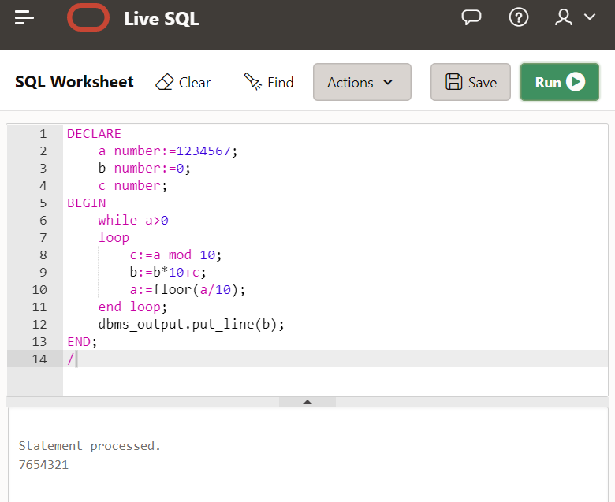

**Q3) Write a PL/SQL code to find the greatest number among three with Anonymous blocks.**

DECLARE

a integer:=12;

b integer:=123;

c integer:=3;

m integer;

BEGIN

m:=a;

IF b>m THEN

m:=b;

END IF;

IF c>m THEN

m:=c;

END IF;

dbms_output.put_line(m);

END;

/

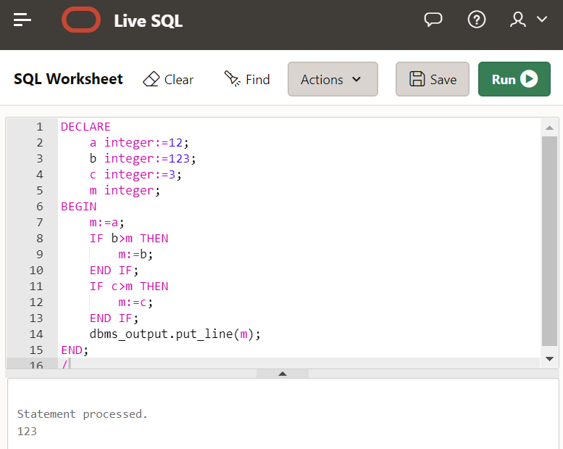

**Q4) Write a PL/SQL code to calculate the area of a circle where radius takes values from 3 to 7. Store the calculated area in Table AREA. The schema of table is given below: AREA (Radius, Area)**

create table Area

(

radius float NOT NULL,

area float NOT NULL

);

DECLARE

r float:=5;

ar float;

pi constant number:=3.14;

BEGIN

ar:=pi*r*r;

insert into Area (radius, area) values (r, ar);

dbms_output.put_line(ar);

END;

/

select * from Area;

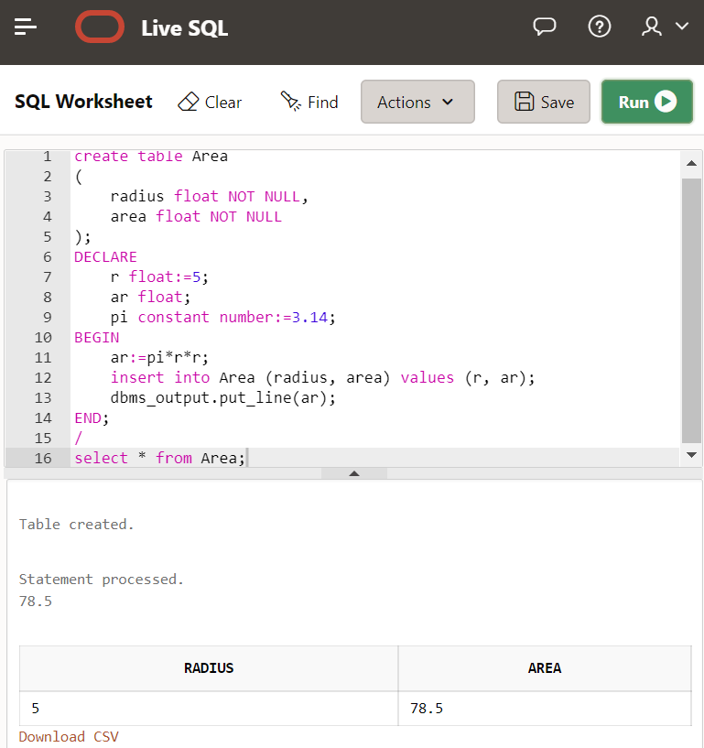

**Q5) Write a PL/SQL program to accept a number and find the factorial of the number**

DECLARE

a integer:=6;

b integer:=1;

BEGIN

IF a=0 THEN

dbms_output.put_line(b);

ELSIF a<0 THEN

dbms_output.put_line('Not Possible');

ELSE

while a>1

loop

b:=b*a;

a:=a-1;

end loop;

dbms_output.put_line(b);

END IF;

END;

/

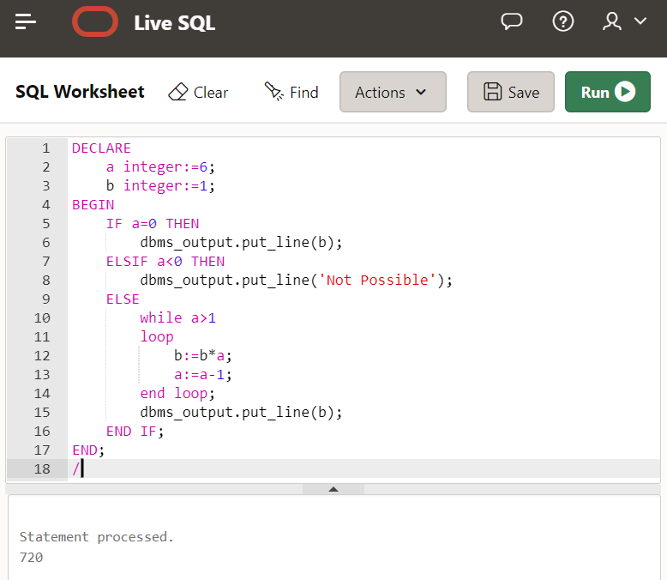

**Q6) Write a PL/SQL program to display the months between two dates of a year**

SELECT MONTHS_BETWEEN (TO_DATE('02-02-2015','MM-DD-YYYY'), TO_DATE('02-06-2014','MM-DD-YYYY') ) "Months" FROM DUAL;

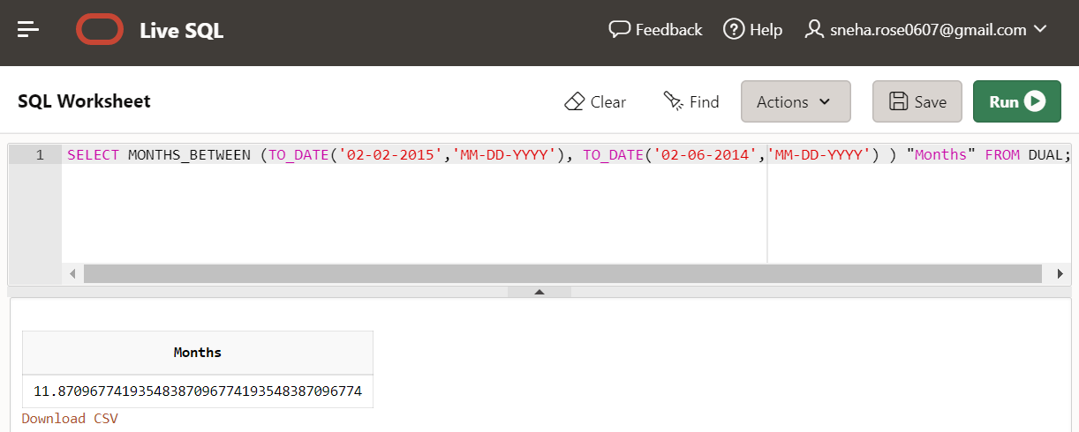

**Q7) Create an Account_Master table & insert the tuples as given the question. Write a PL/SQL code that will accept an account number from user. If the balance of account is less than minimum balance (i.e 1000) deducts Rs 100 from balance. The schema of table is given below: Acc_Master (acct_no, acct_holder_name , Balance);**

CREATE TABLE Account_Master (acct_no INTEGER PRIMARY KEY, acct_holder_name VARCHAR2(10), balance INTEGER);

INSERT INTO Account_Master VALUES (1,'John', 1000);

INSERT INTO Account_Master VALUES (2, 'Denis', 100);

INSERT INTO Account_Master VALUES (3, 'Albert', 1100);

INSERT INTO Account_Master VALUES (4, 'Charles', 700);

INSERT INTO Account_Master VALUES (5, 'Darwin', 1700);

BEGIN

UPDATE Account_Master

SET balance = balance-100

WHERE balance < 1000;

END;

/

SELECT * FROM Account_Master;

